|  |  |  |  |
| --- | --- | --- | --- |
| SNO | Name of Practical | Submitted on | Signature |
| 1 | Write a program to find the sum of two numbers. |  |  |
| 2 | Write a program to swap two numbers using a third variable |  |  |
| 3 | Write a program to swap two numbers without a third variable. |  |  |
| 4 | Write a program to input principle amount, rate and time from user and calculate the simple interest. |  |  |
| 5 | Write a program to input a temperature in Fahrenheit and convert it into Celsius |  |  |
| 6 | Write a program to input distance between two cities in KM and convert it into Centimetre, metre, feet and inches. |  |  |
| 7 | Write a program to convert a float value into Integer type using type casting. |  |  |
| 8 | Write a program to find corresponding ASCII value of given integer. |  |  |
| 9 | Write to program to check whether given number is odd or even. |  |  |
| 10 | Write a program to check whether given number is Armstrong number or not. |  |  |
| 11 | Write to program to find the largest of three given numbers |  |  |
| 12 | Display first n natural numbers and their sum. |  |  |
| 13 | Write a program to display n number of Fibonacci series. |  |  |
| 14 | Write a program to display the following pattern  1  1 2 |  |  |
| 15 | Write a program to display the following pattern  1  121 |  |  |
| 16 | WAP to convert binary number into decimal and binary number into decimal. |  |  |
| 17 | WAP to find a number in an array and print number of times it appears in the array. |  |  |
| 18 | WAP to find sum of a matrix. |  |  |
| 19 | WAP to find transpose of a matrix |  |  |
| 20 | .WAP to print lower triangle of a matrix |  |  |
| 21 | WAP to print upper triangle of a matrix. |  |  |
| 22 | WAP to find length of a string without using any library function. |  |  |
| 23 | WAP to find no. of vowels and consonants present in a given string |  |  |
| 24 | WAP to sort a string based on its elements. |  |  |
| 25 | WAP to find no. of words in a string. |  |  |
| 27 | WAP to make a calculator using function. |  |  |
| 28 | WAP to multiply two matrix. |  |  |
| 29 | WAP to find factorial of a number  a) with returning value.  b) without returning value |  |  |
| 30 | WAP to swap two numbers using pointer. |  |  |
| 31 | WAP to multiply every element of an array using pointer and functions. Function should return the array. |  |  |
| 32 | WAP to search an element from an array  a) by recursive method.  b) by iterative method. (normal) |  |  |
| 33 | WAP to sort a number array using optimised bubble sorting. |  |  |
| 34 | WAP to sort a number array using insertion sorting. |  |  |
| 35 | WAP to sort a number array using selection sorting. |  |  |
| 36 | WAP to read the information of a student from the keyboard and print the same on the screen using structure. |  |  |
| 37 | WAP to read information of n number of students from keyboard and and print the same by using structure. |  |  |
| 38 | WAP to print a file on screen |  |  |
| 39 | WAP to copy the contents of one file to another file. |  |  |
| 40 | WAP to create a file named INPUT which contain a series of integers. Now read these integers from INPUT file and write all even numbers into a file to be called EVEN and all odd numbers into a file to be called ODD. |  |  |

1. Write a program to find the sum of two numbers.

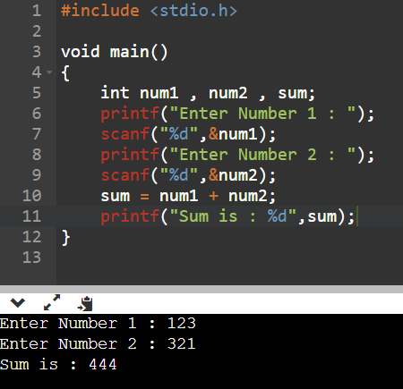

2. Write a program to swap two numbers using a third variable.

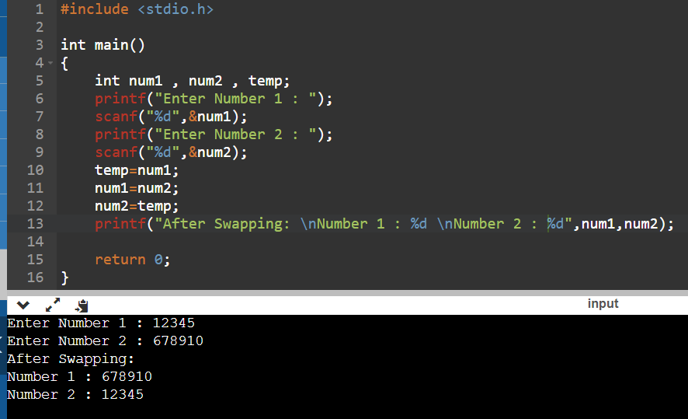

3. Write a program to swap two numbers without a third variable.

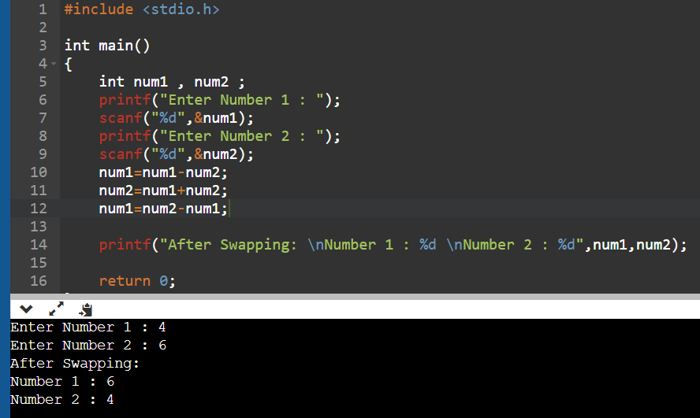

4. Write a program to input principle amount, rate and time from user and calculate the simple interest.

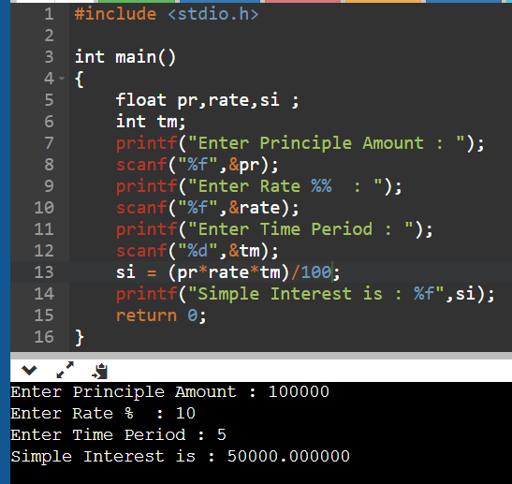

5. Write a program to input a temperature in Fahrenheit and convert it into Celsius.

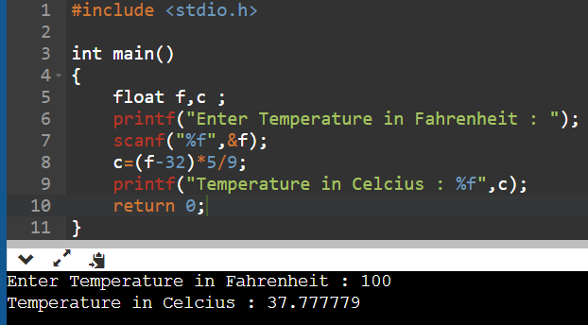

6. Write a program to input distance between two cities in KM and convert it into Centimetre, metre, feet and inches.

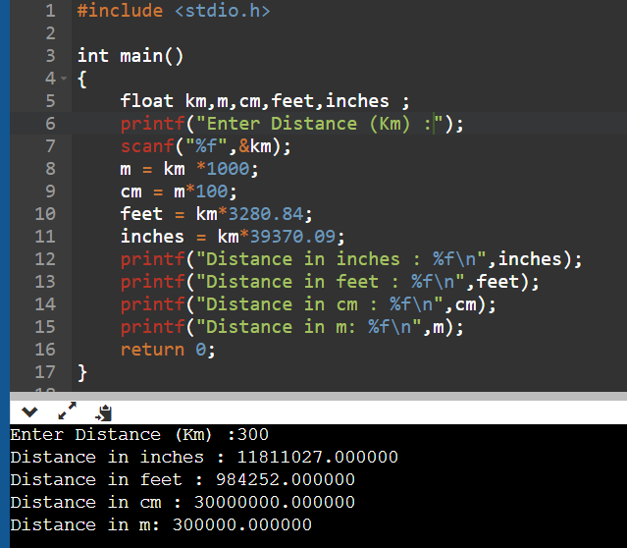

7. Write a program to convert a float value into Integer type using type casting.

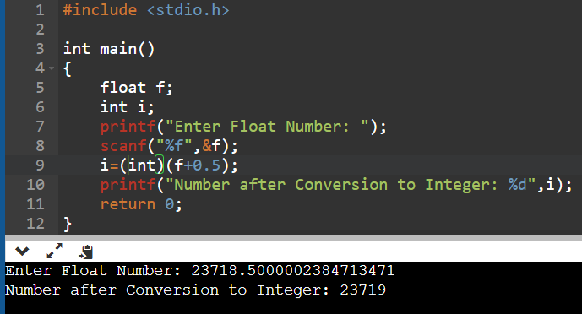

8. Write a program to find corresponding ASCII value of given integer.

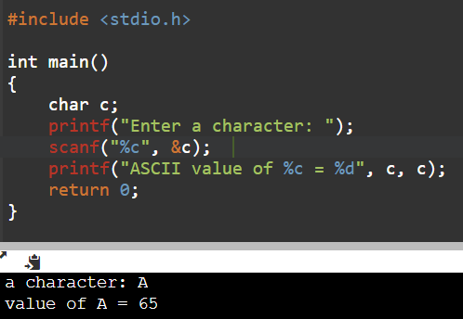

9. Write to program to check whether given number is odd or even.

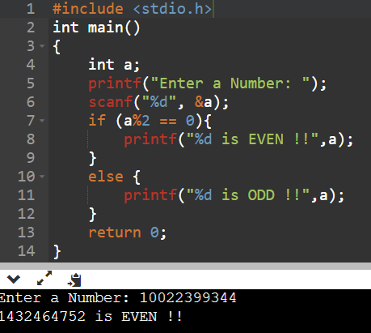

10. Write a program to check whether given number is Armstrong number or not.

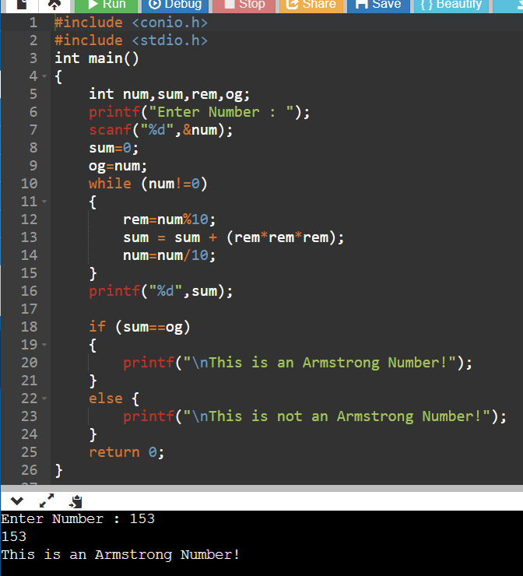

11. Write to program to find the largest of three given numbers.

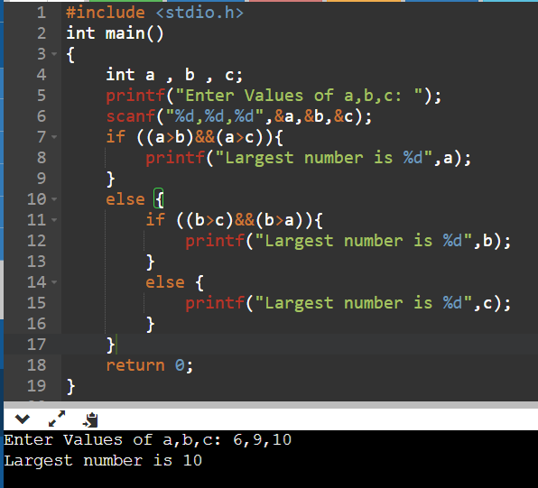

12. Display first n natural numbers and their sum.

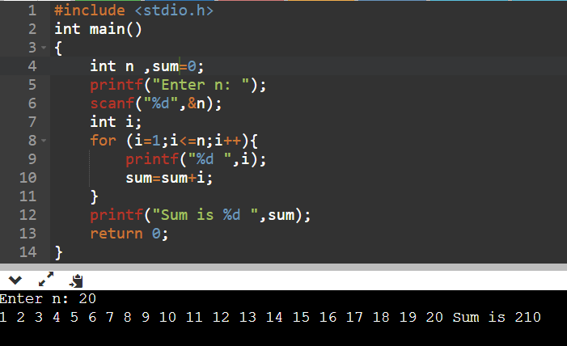

13. Write a program to display n number of Fibonacci series.

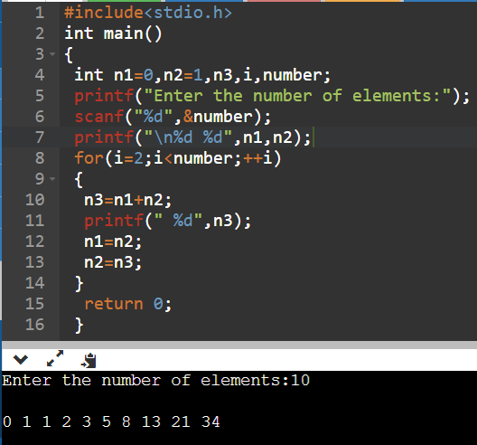

14. Write a program to display the following pattern

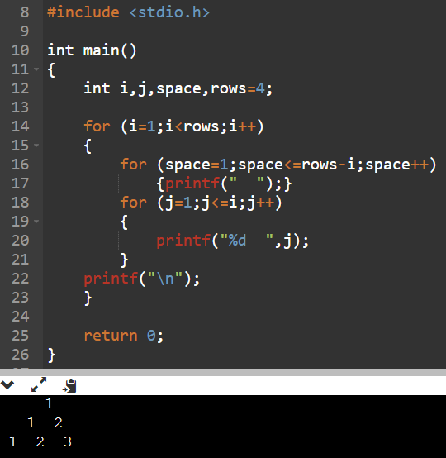

15. Write a program to display the following pattern

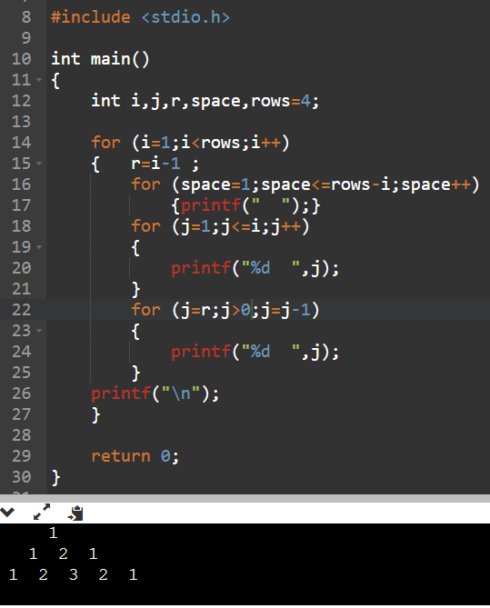

16. WAP to convert binary number into decimal and binary number into decimal.

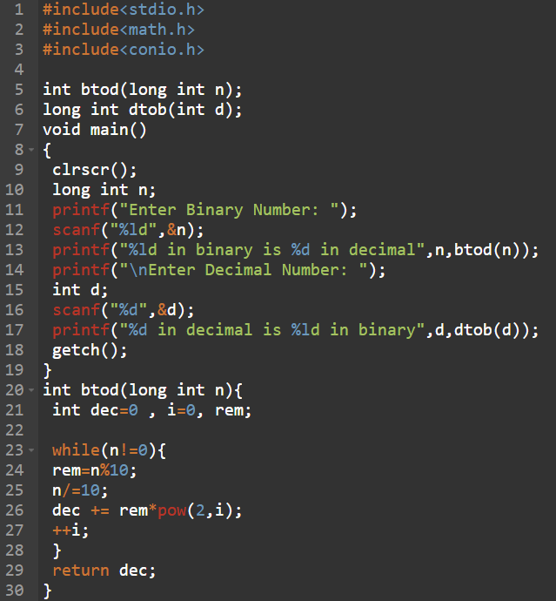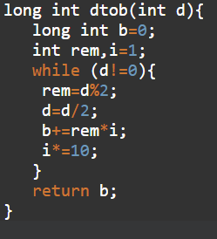

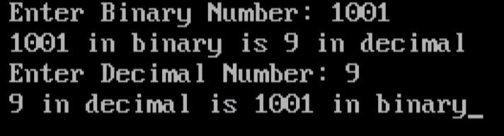

17. WAP to find a number in an array and print number of times it appears in the array.

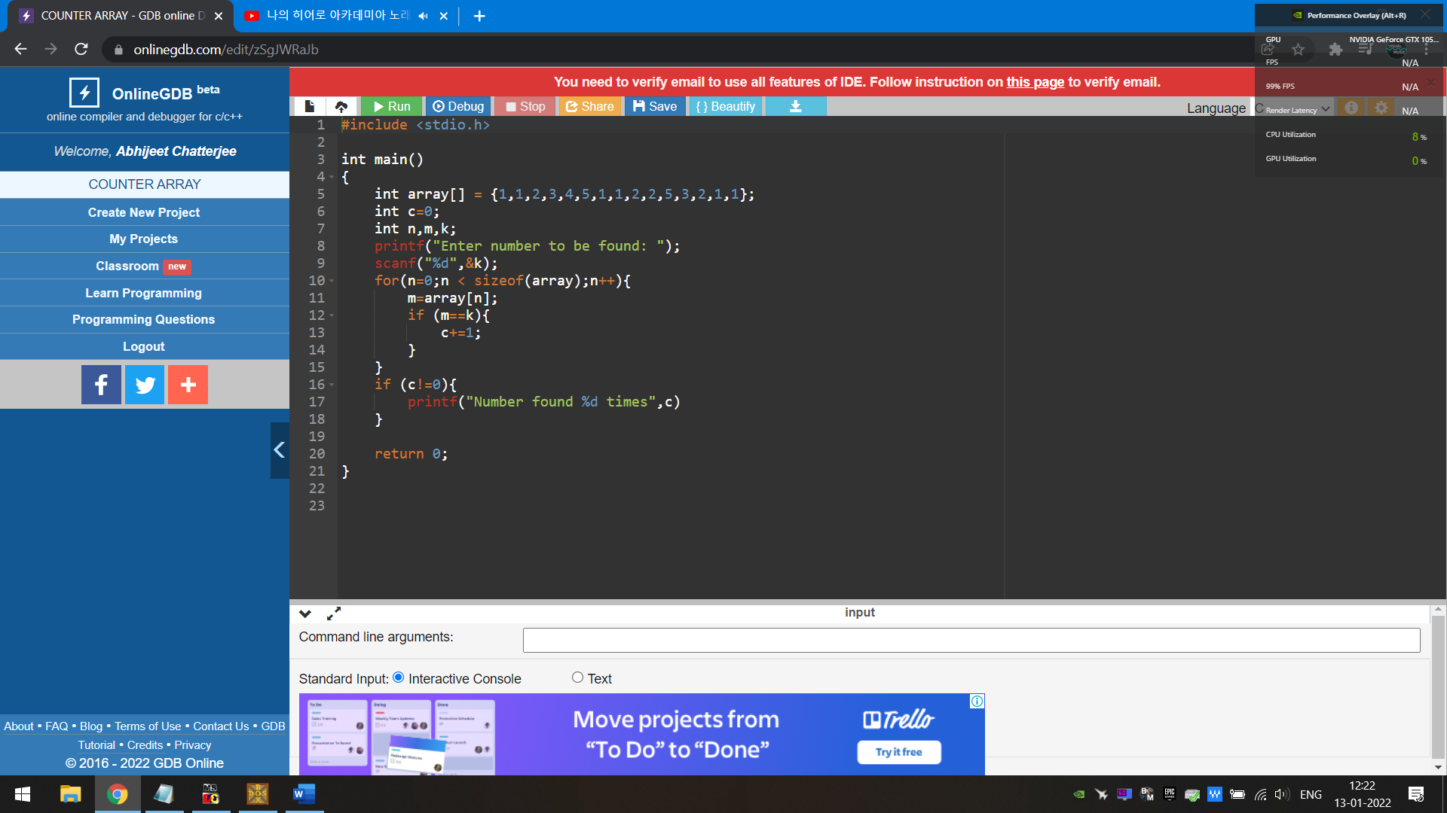

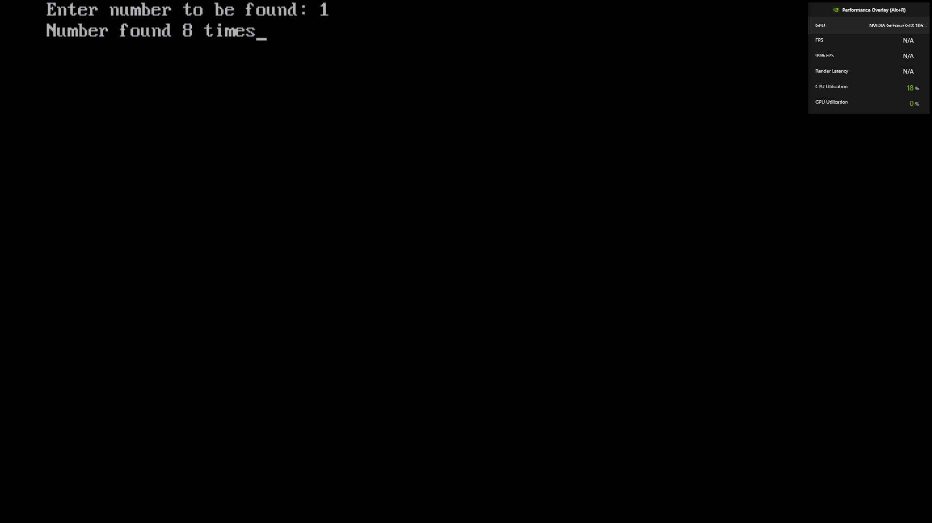

18. WAP to find sum of a matrix.

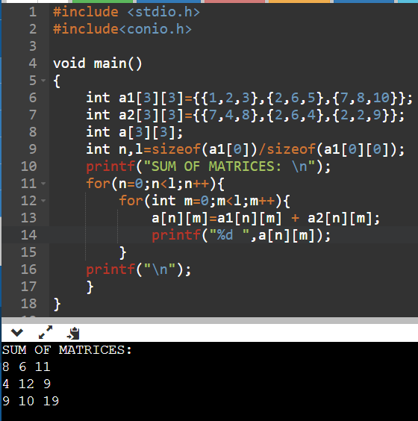

19. WAP to find transpose of a matrix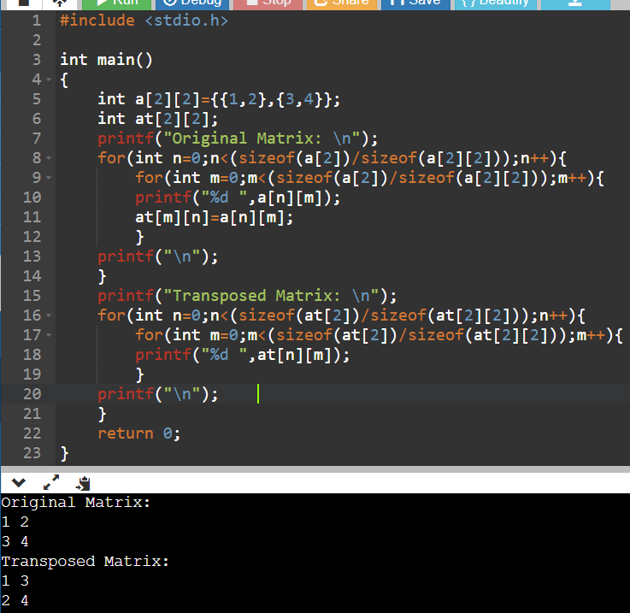

20. WAP to print lower triangle of a matrix.

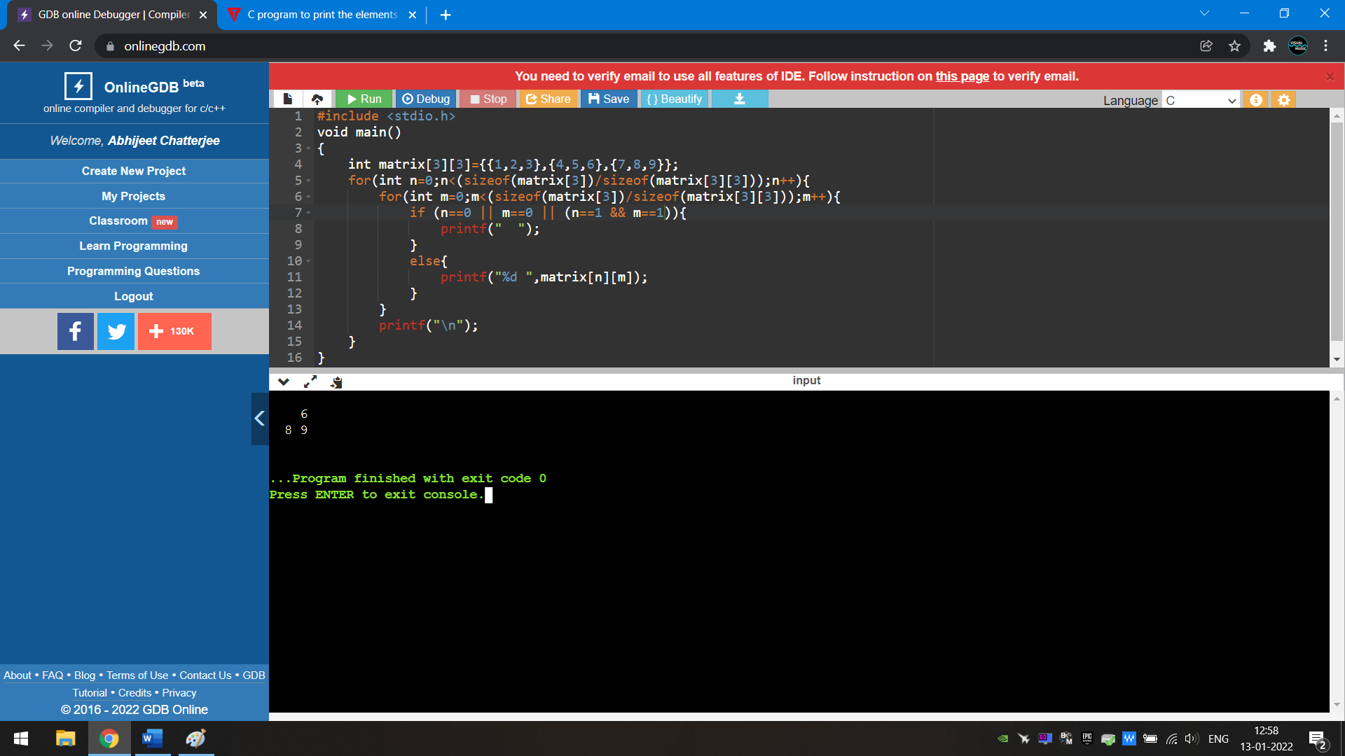

21. WAP to print upper triangle of a matrix.

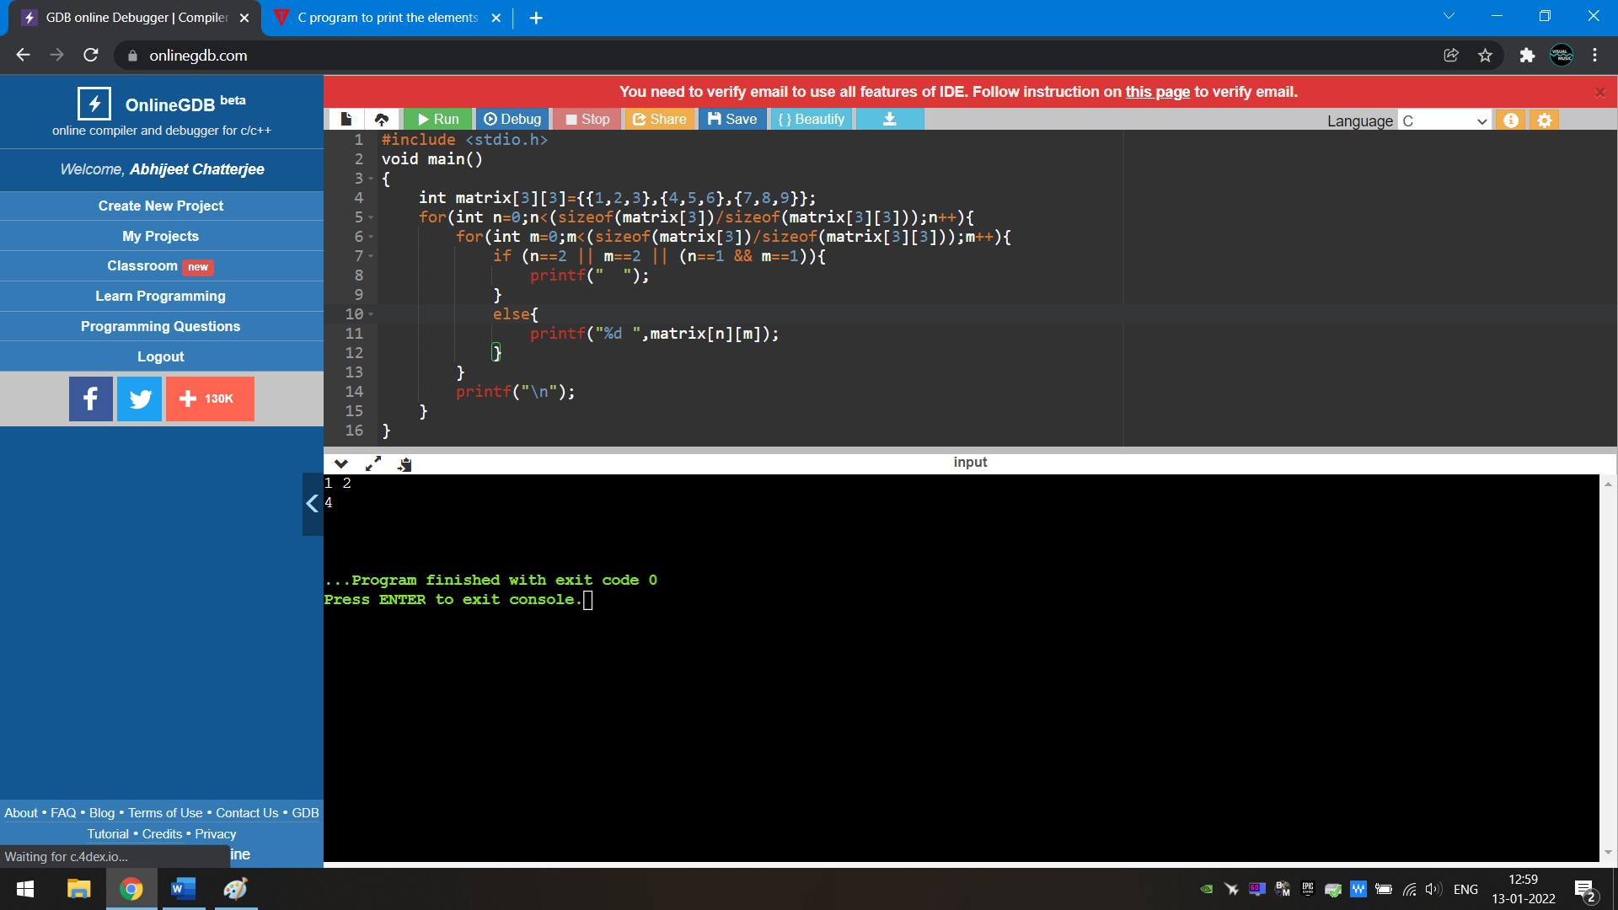

22. WAP to find length of a string without using any library function.

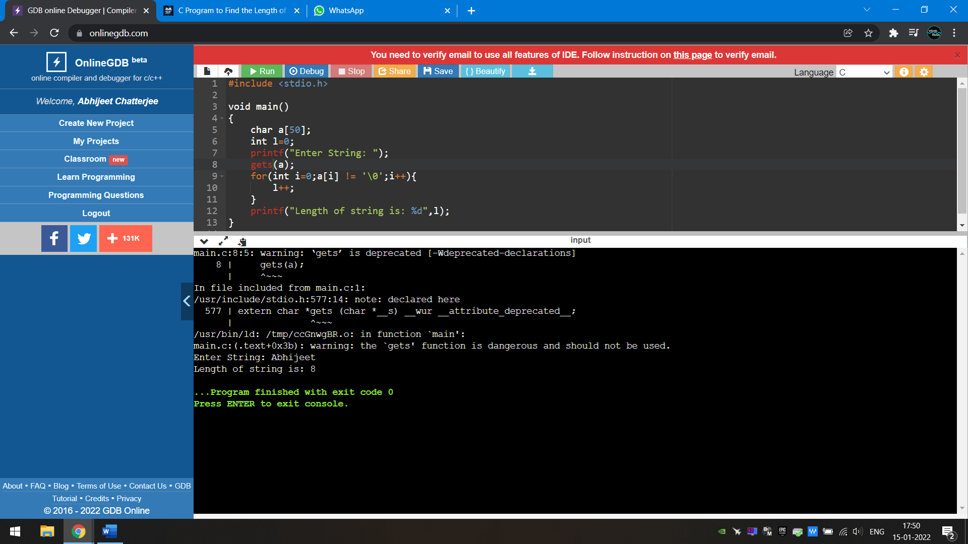 

23. WAP to find no. of vowels and consonants present in a given string.

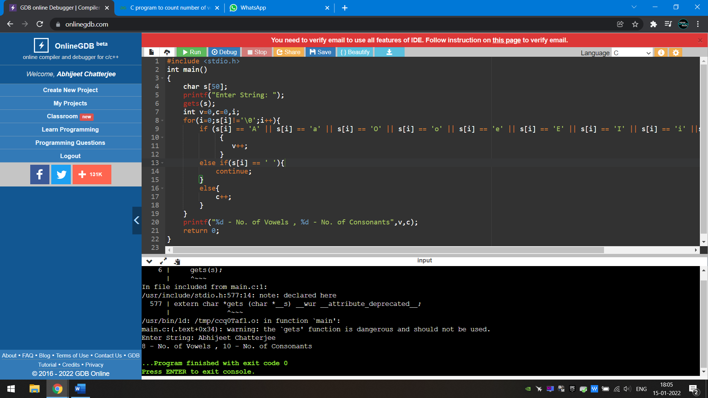

24. WAP to sort a string based on its elements.

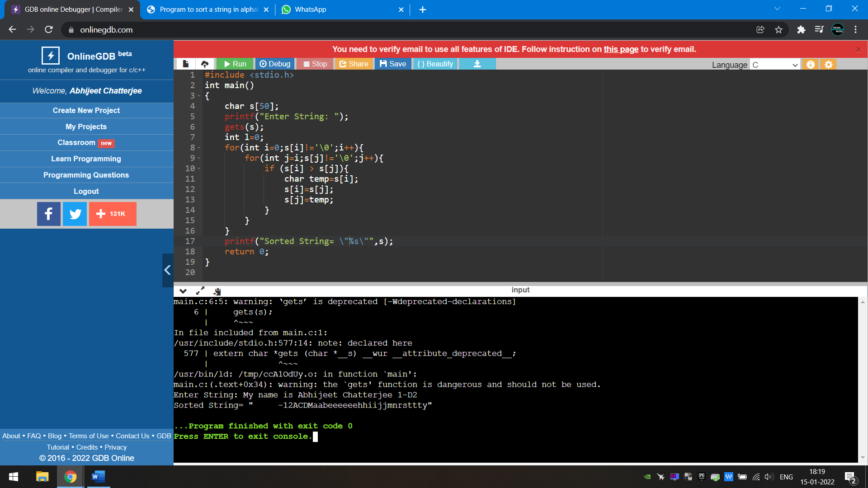 

25. WAP to find no. of words in a string.

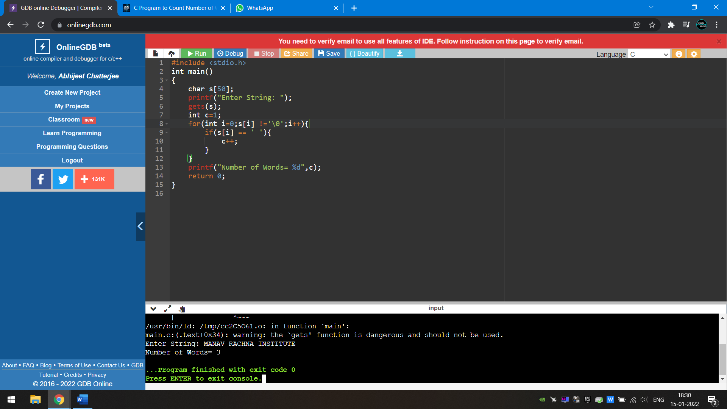



27. WAP to make a calculator using function.

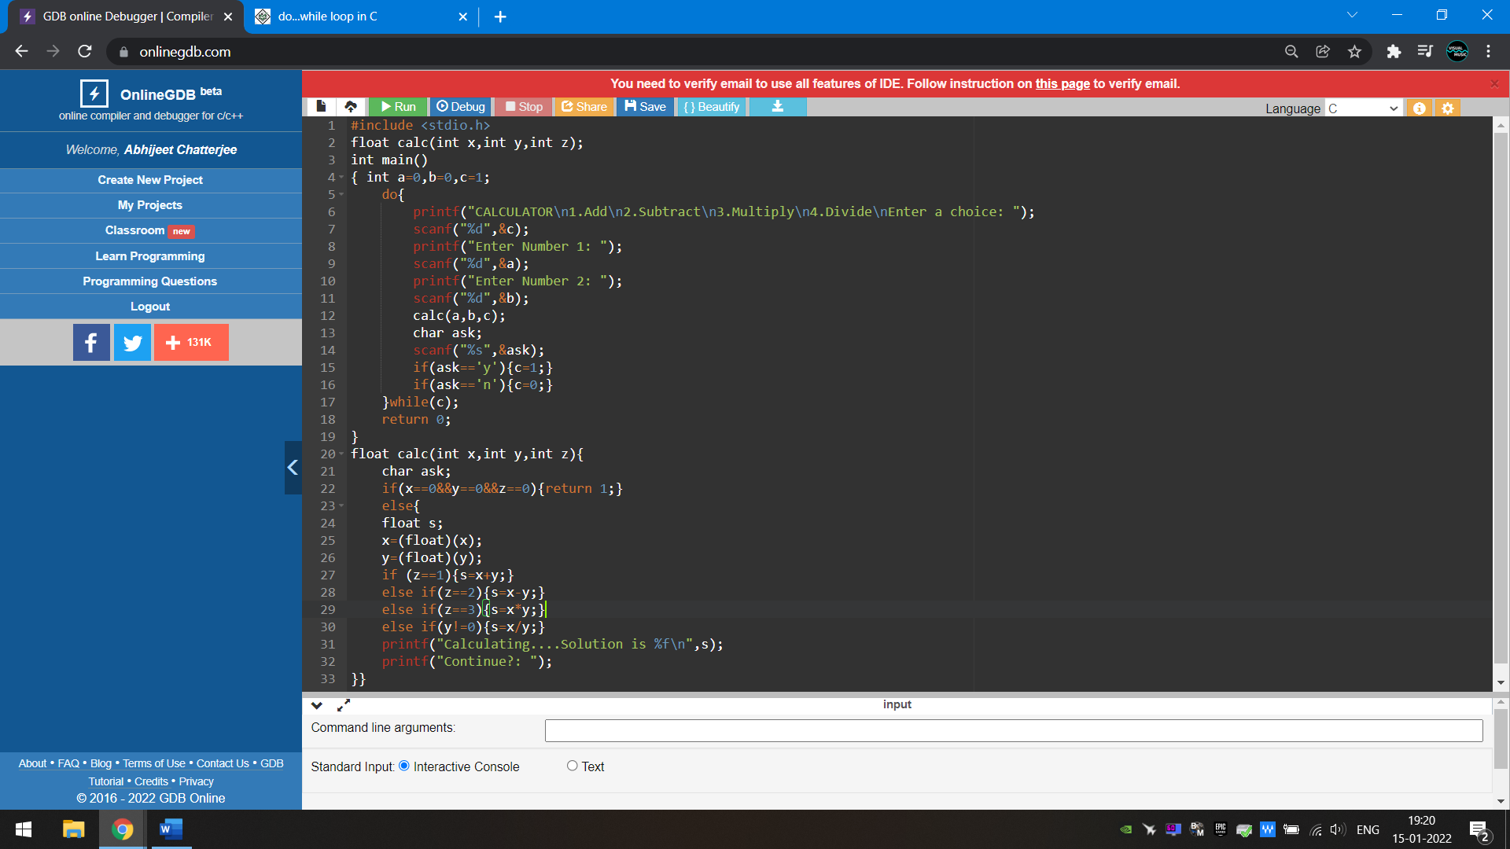

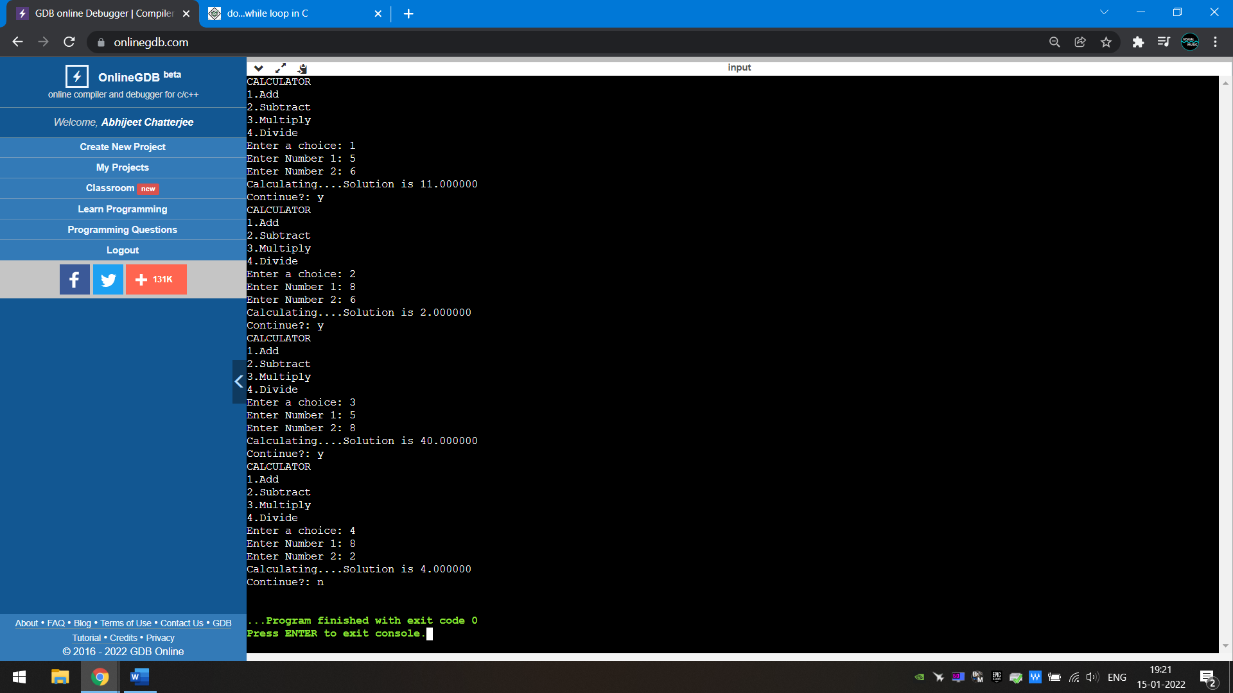

28. WAP to multiply two matrix.

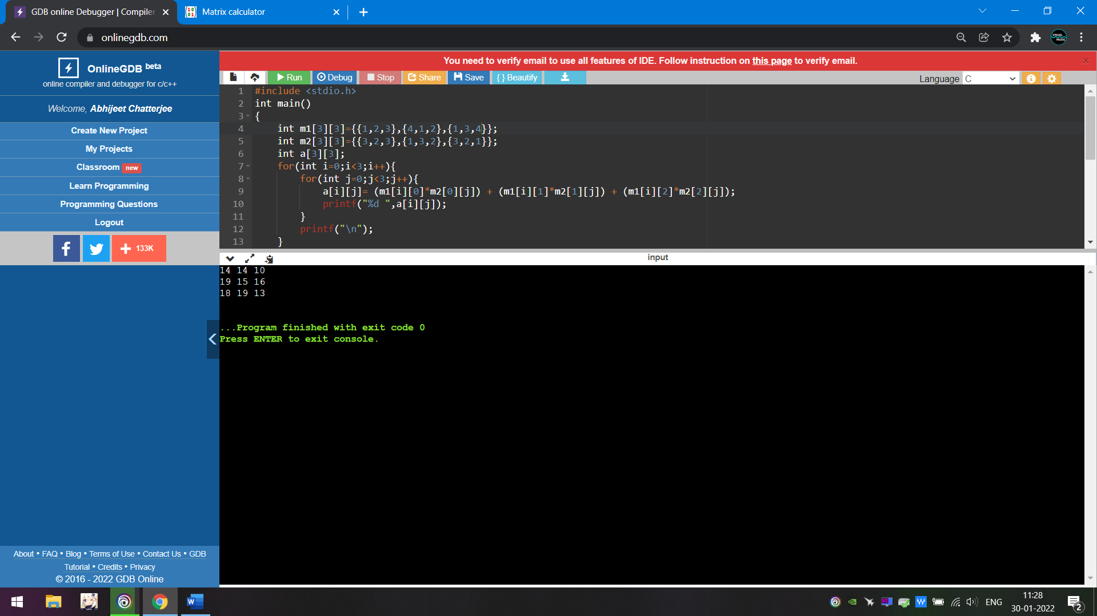



29. WAP to find factorial of a number

a) with returning value.

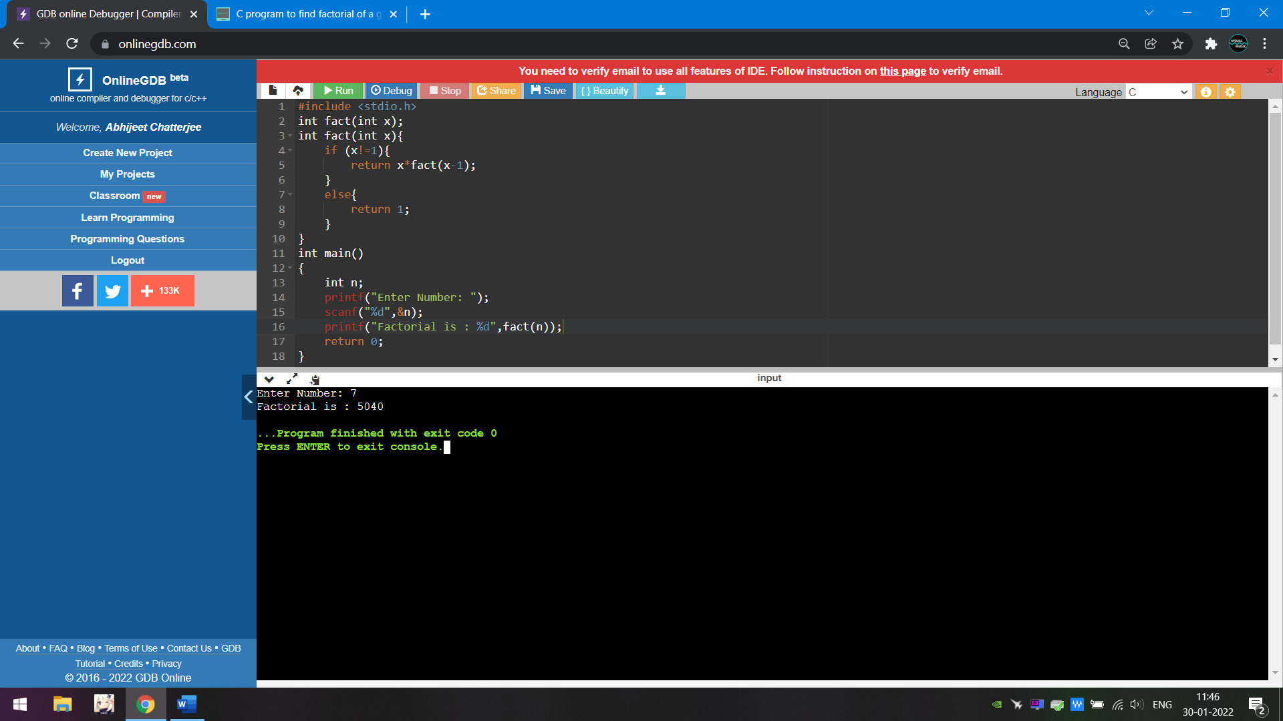

b) without returning value.

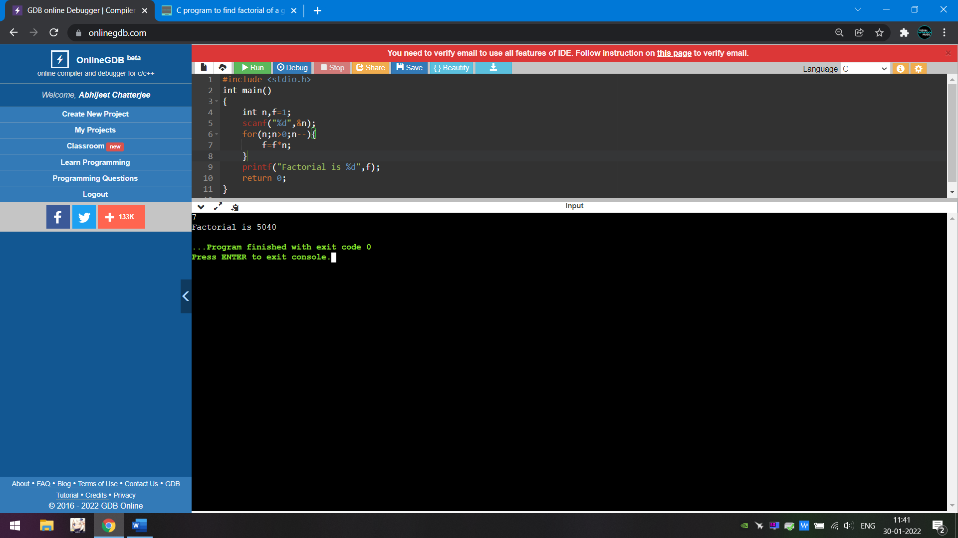

30. WAP to swap two numbers using pointer.

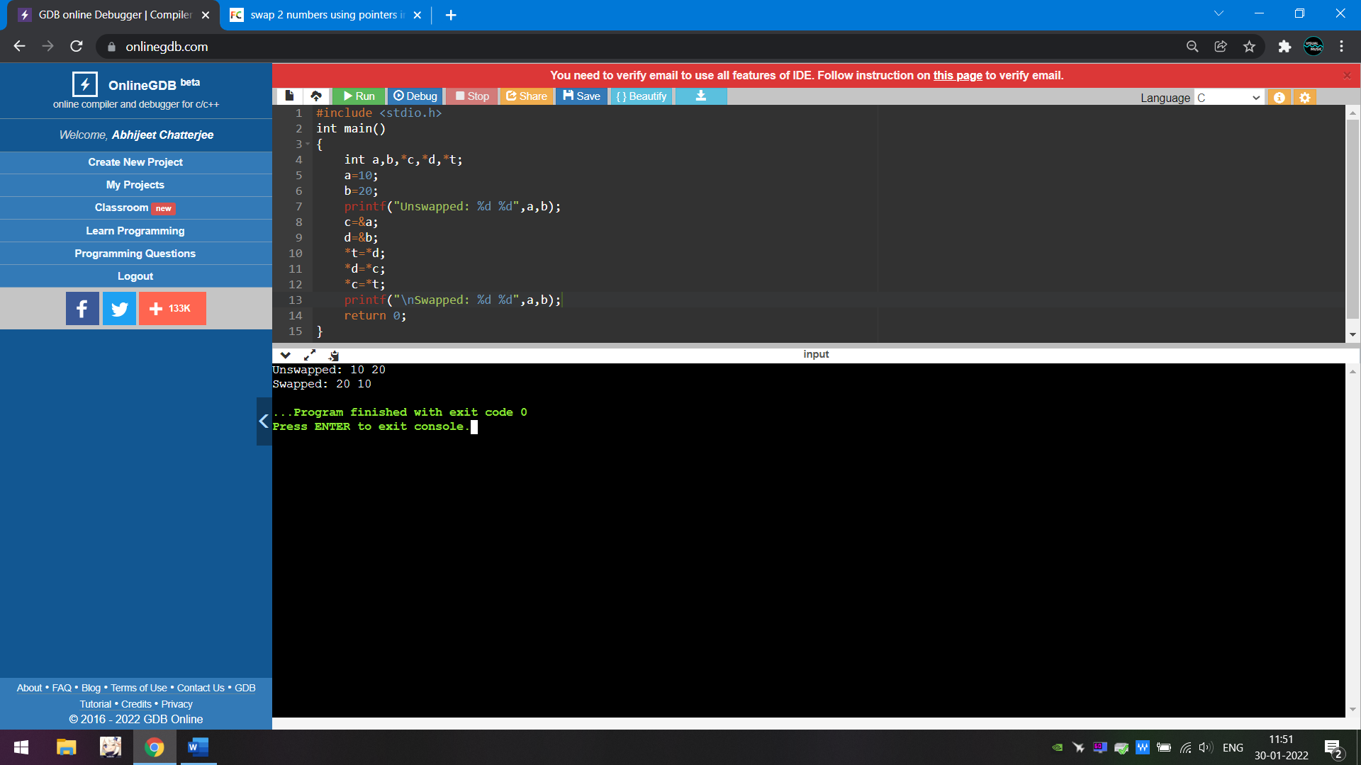

31) WAP to multiply every element of an array using pointer and functions. Function should return the array.

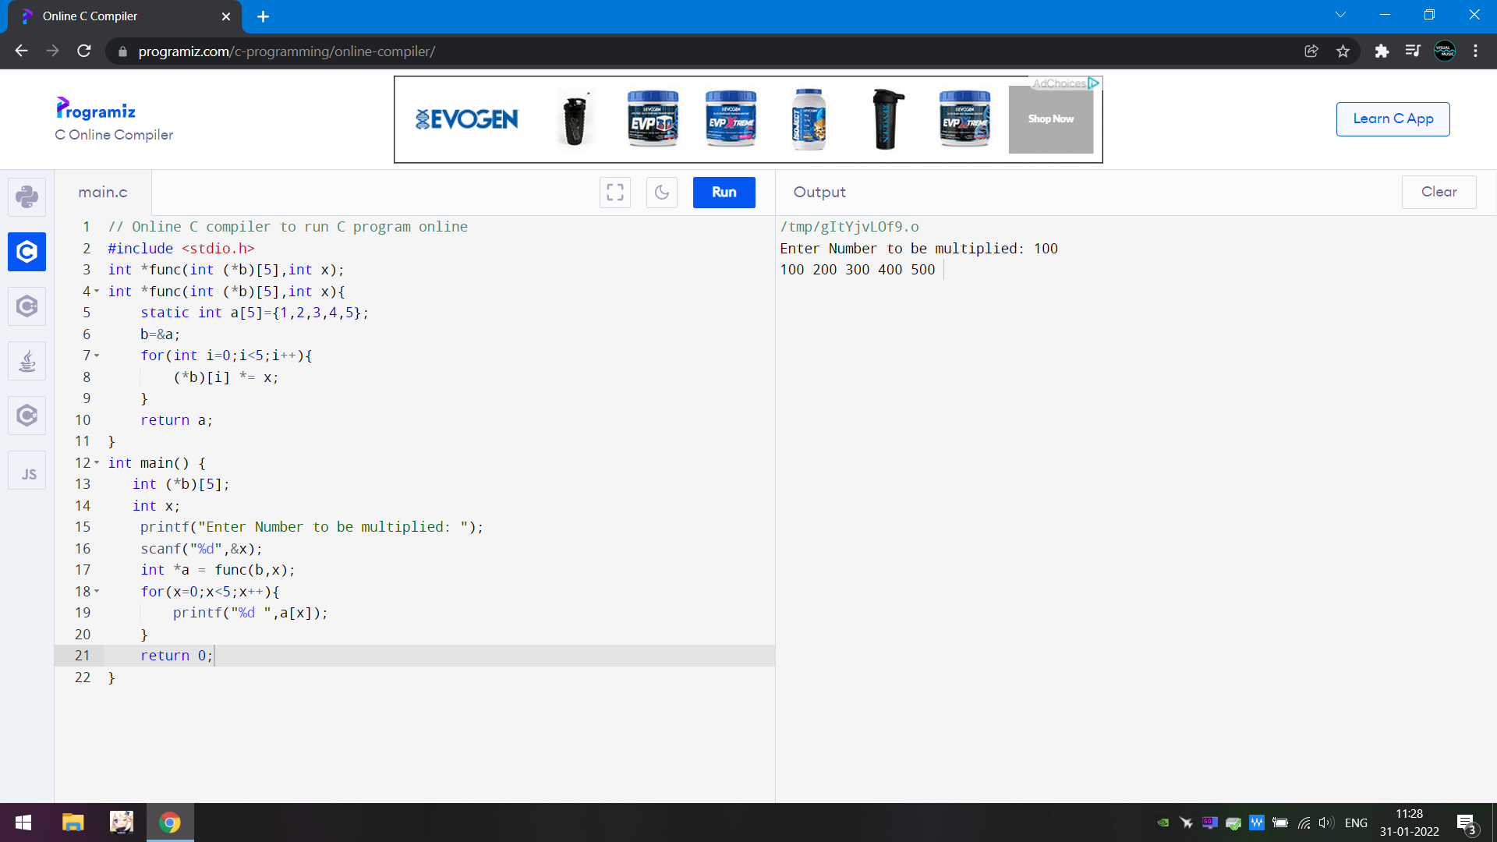



32) WAP to search an element from an array

a) by recursive method.

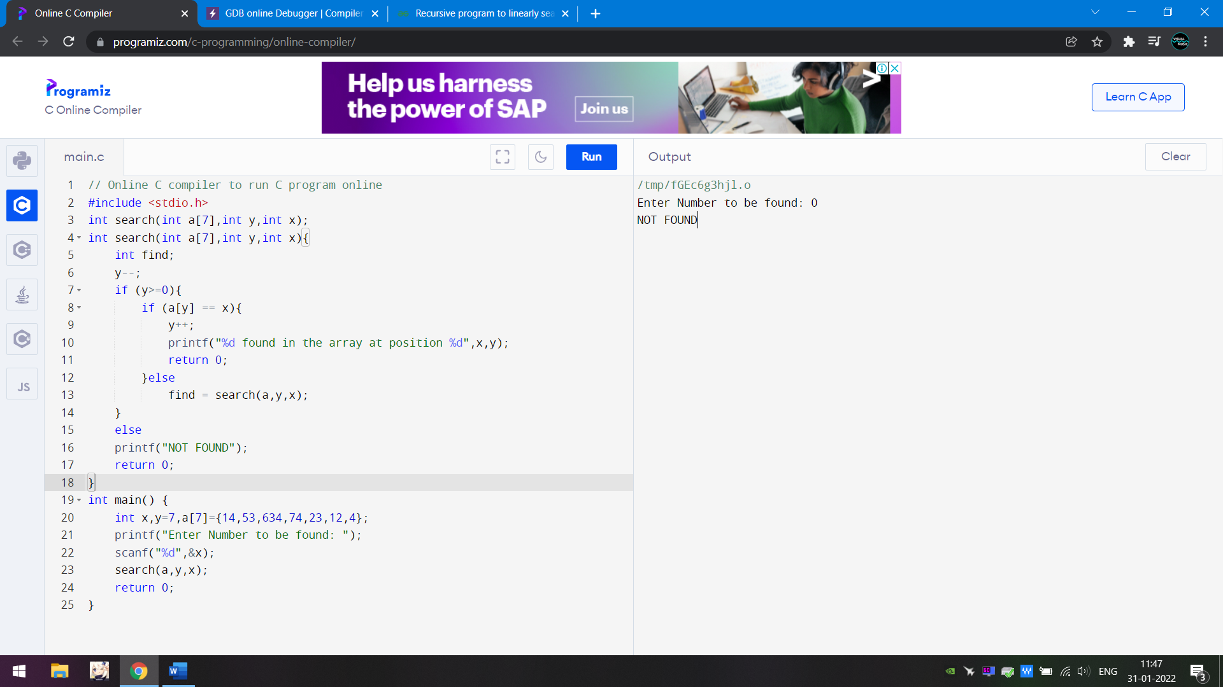

 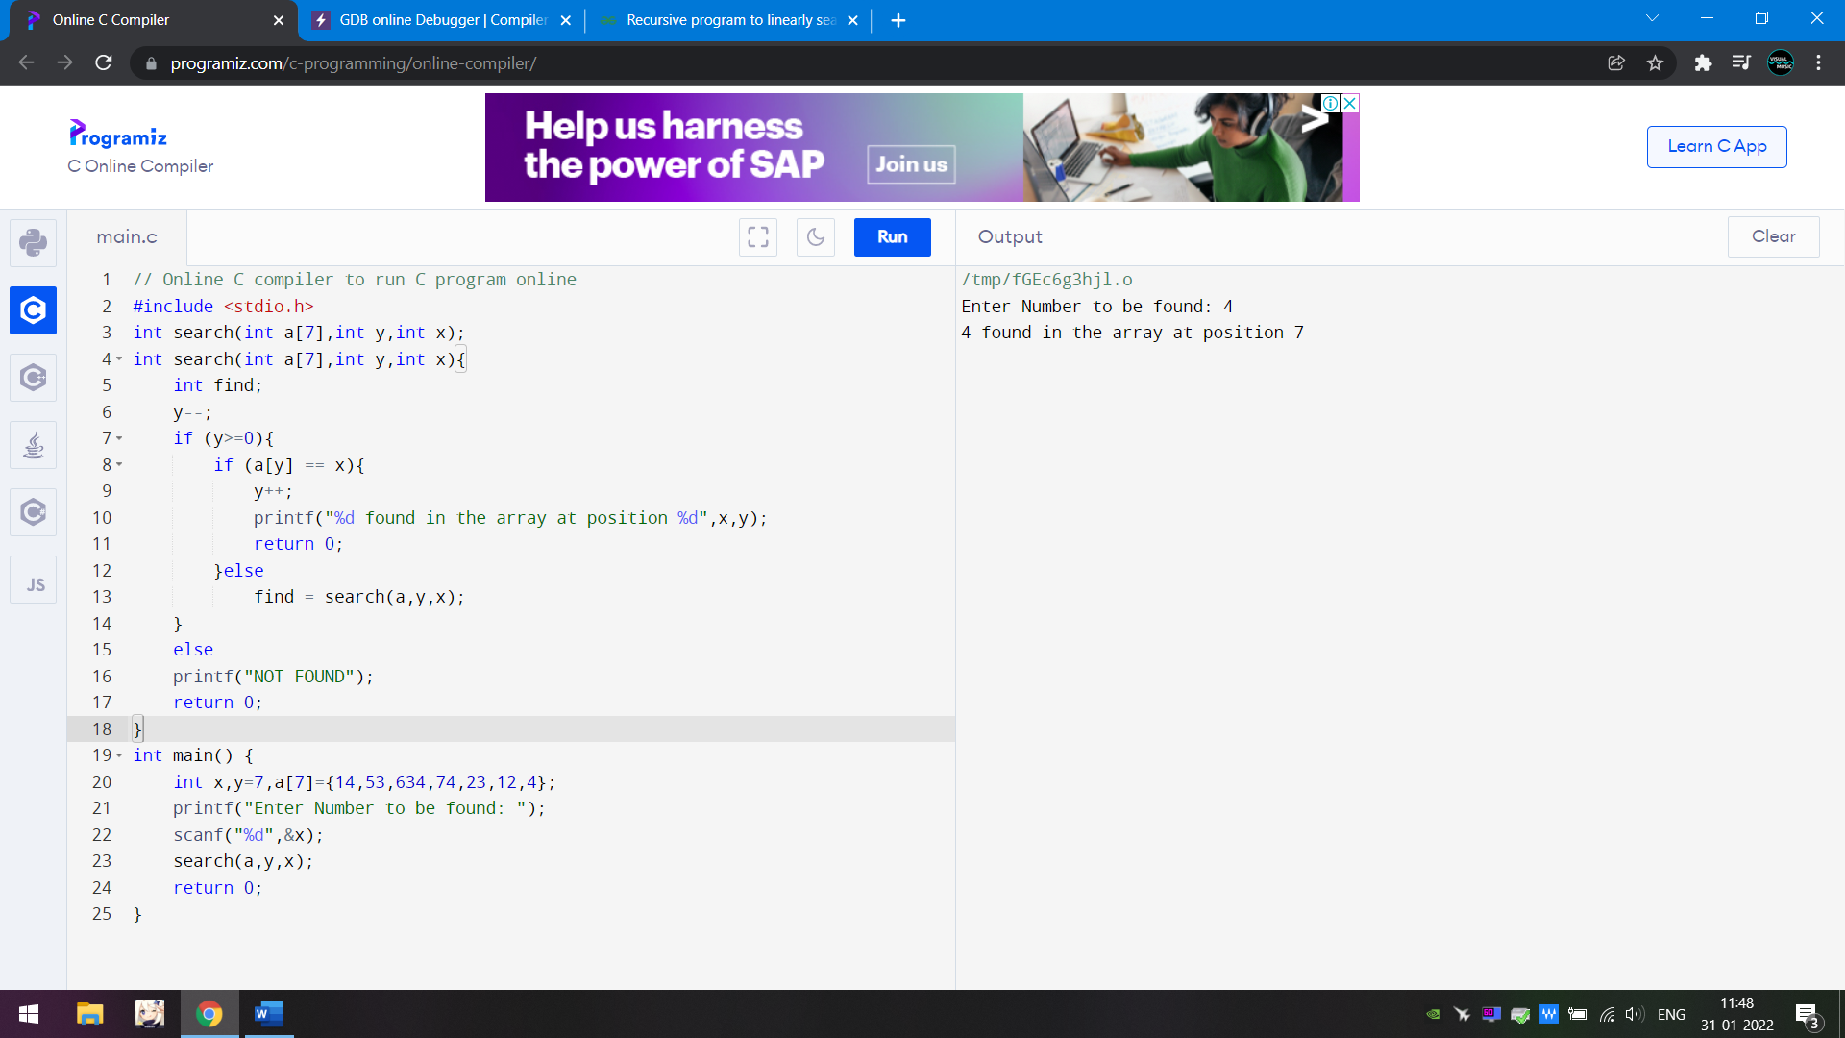

b) by iterative method. (normal)

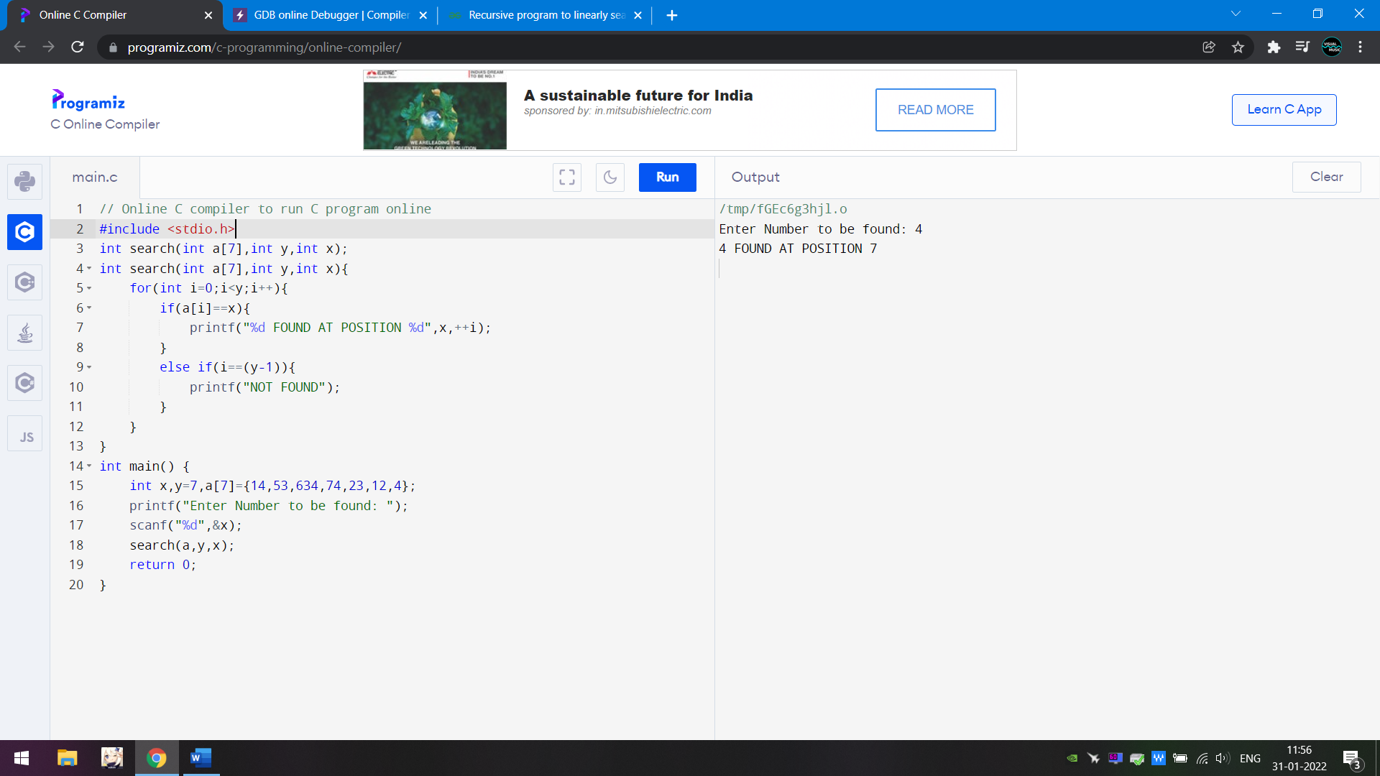 

33) WAP to sort a number array using optimised bubble sorting.

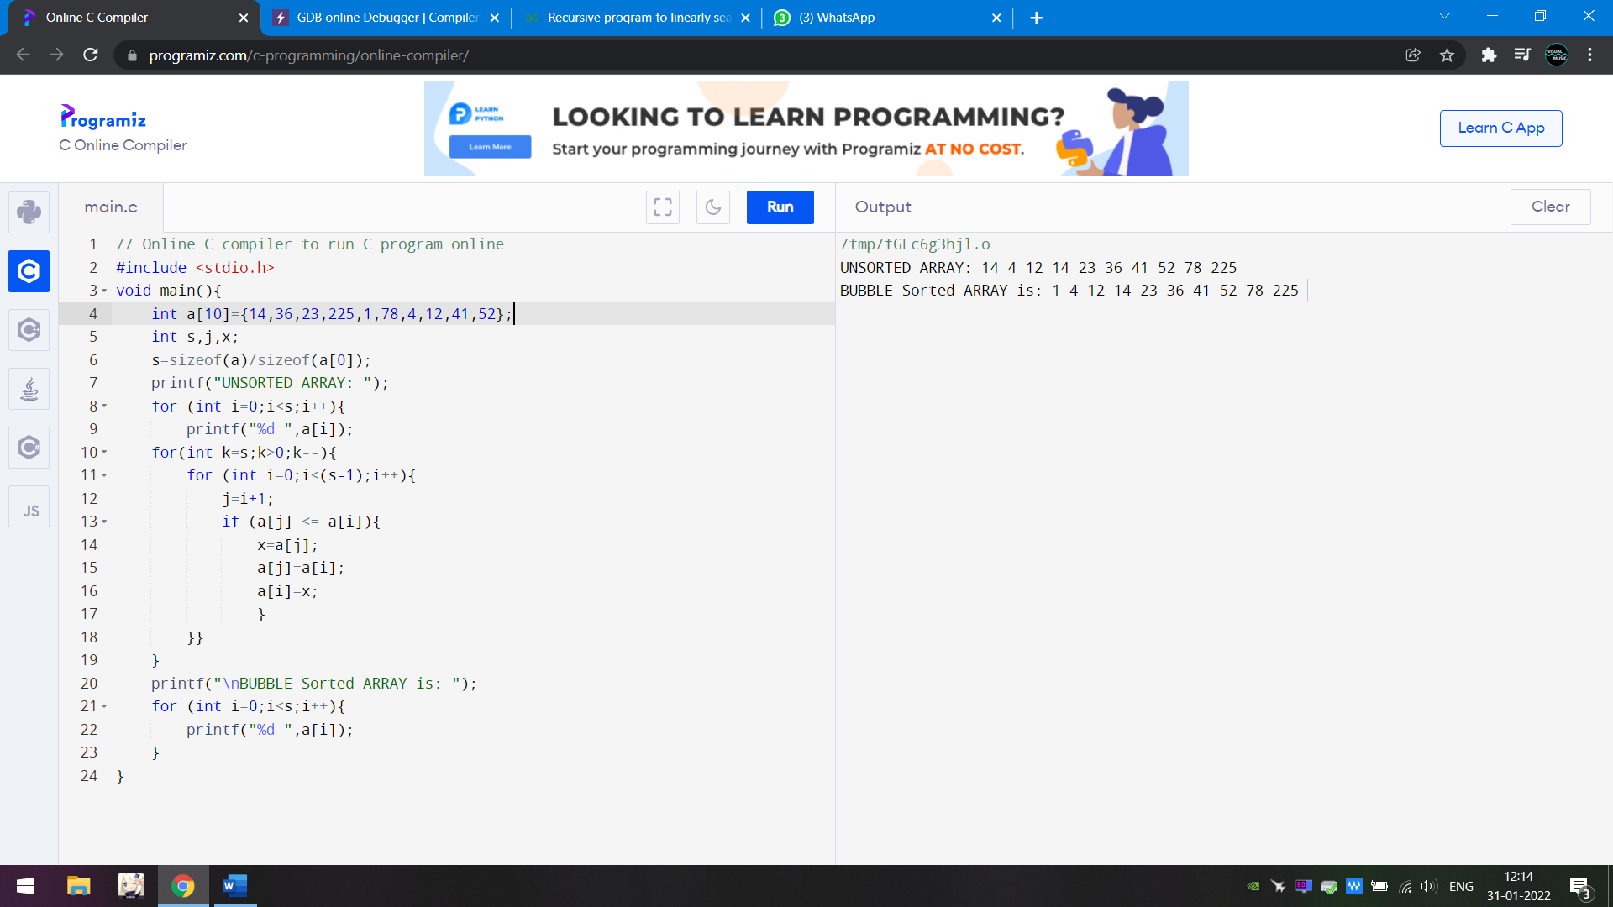



34) WAP to sort a number array using insertion sorting.

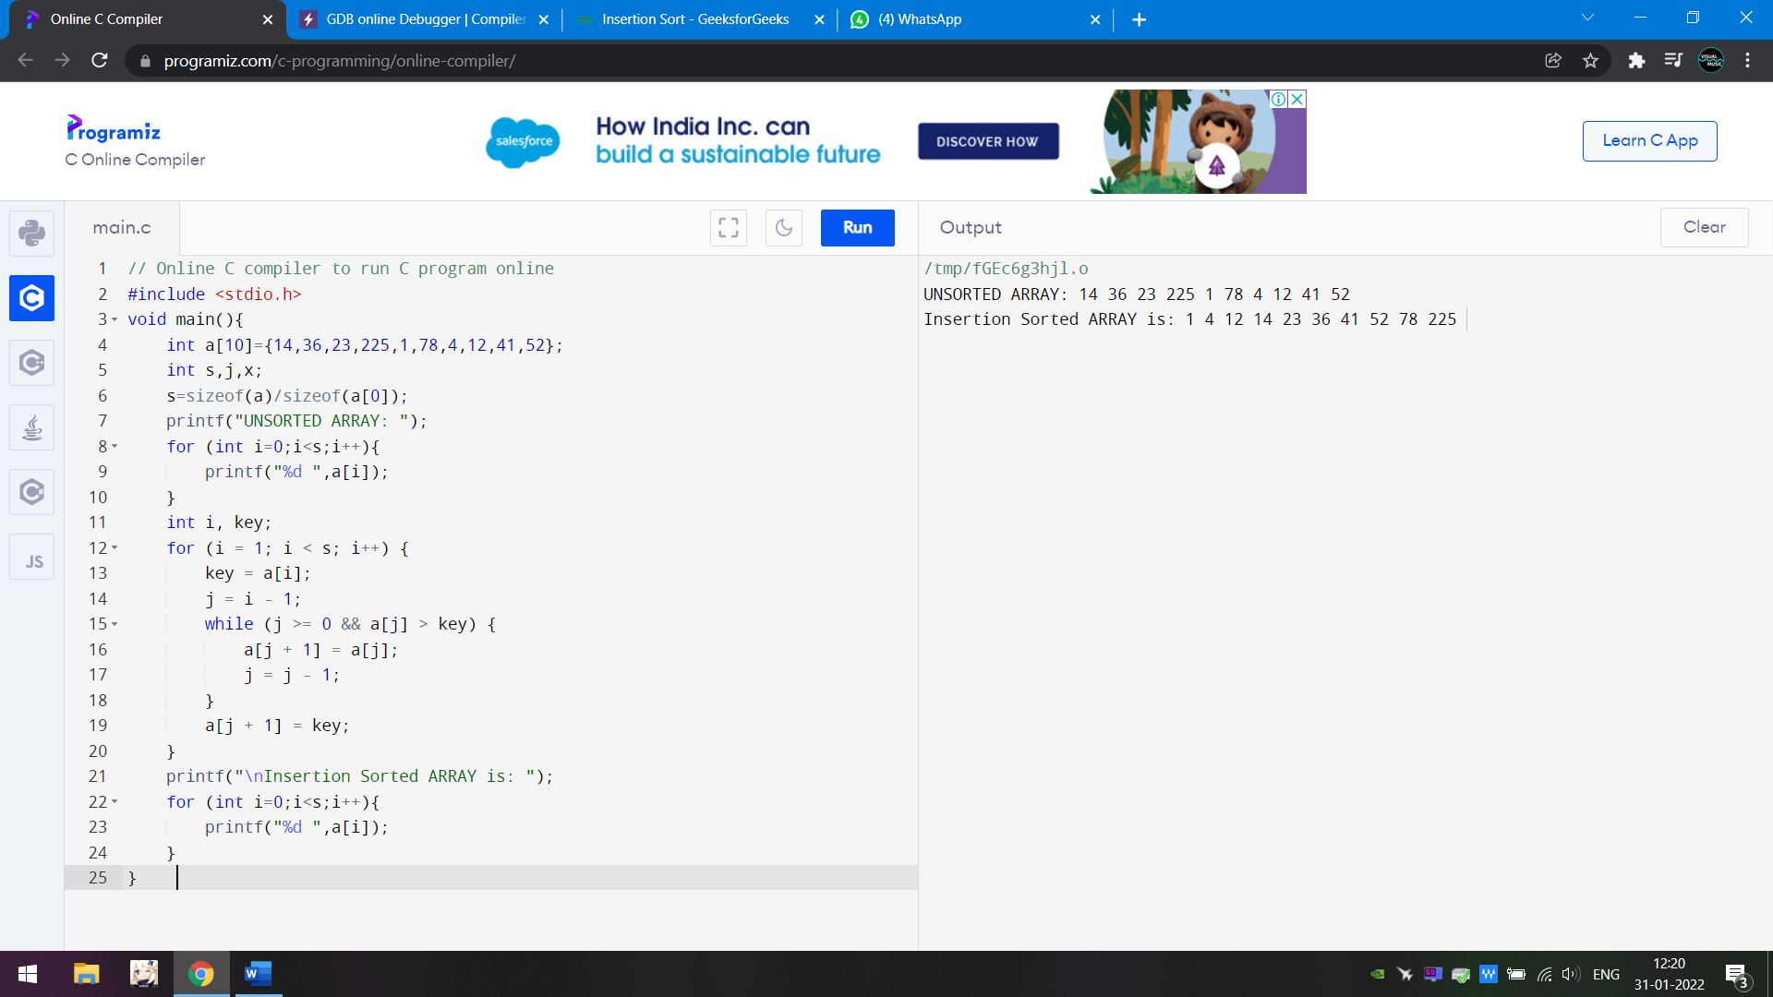 

35) WAP to sort a number array using selection sorting.

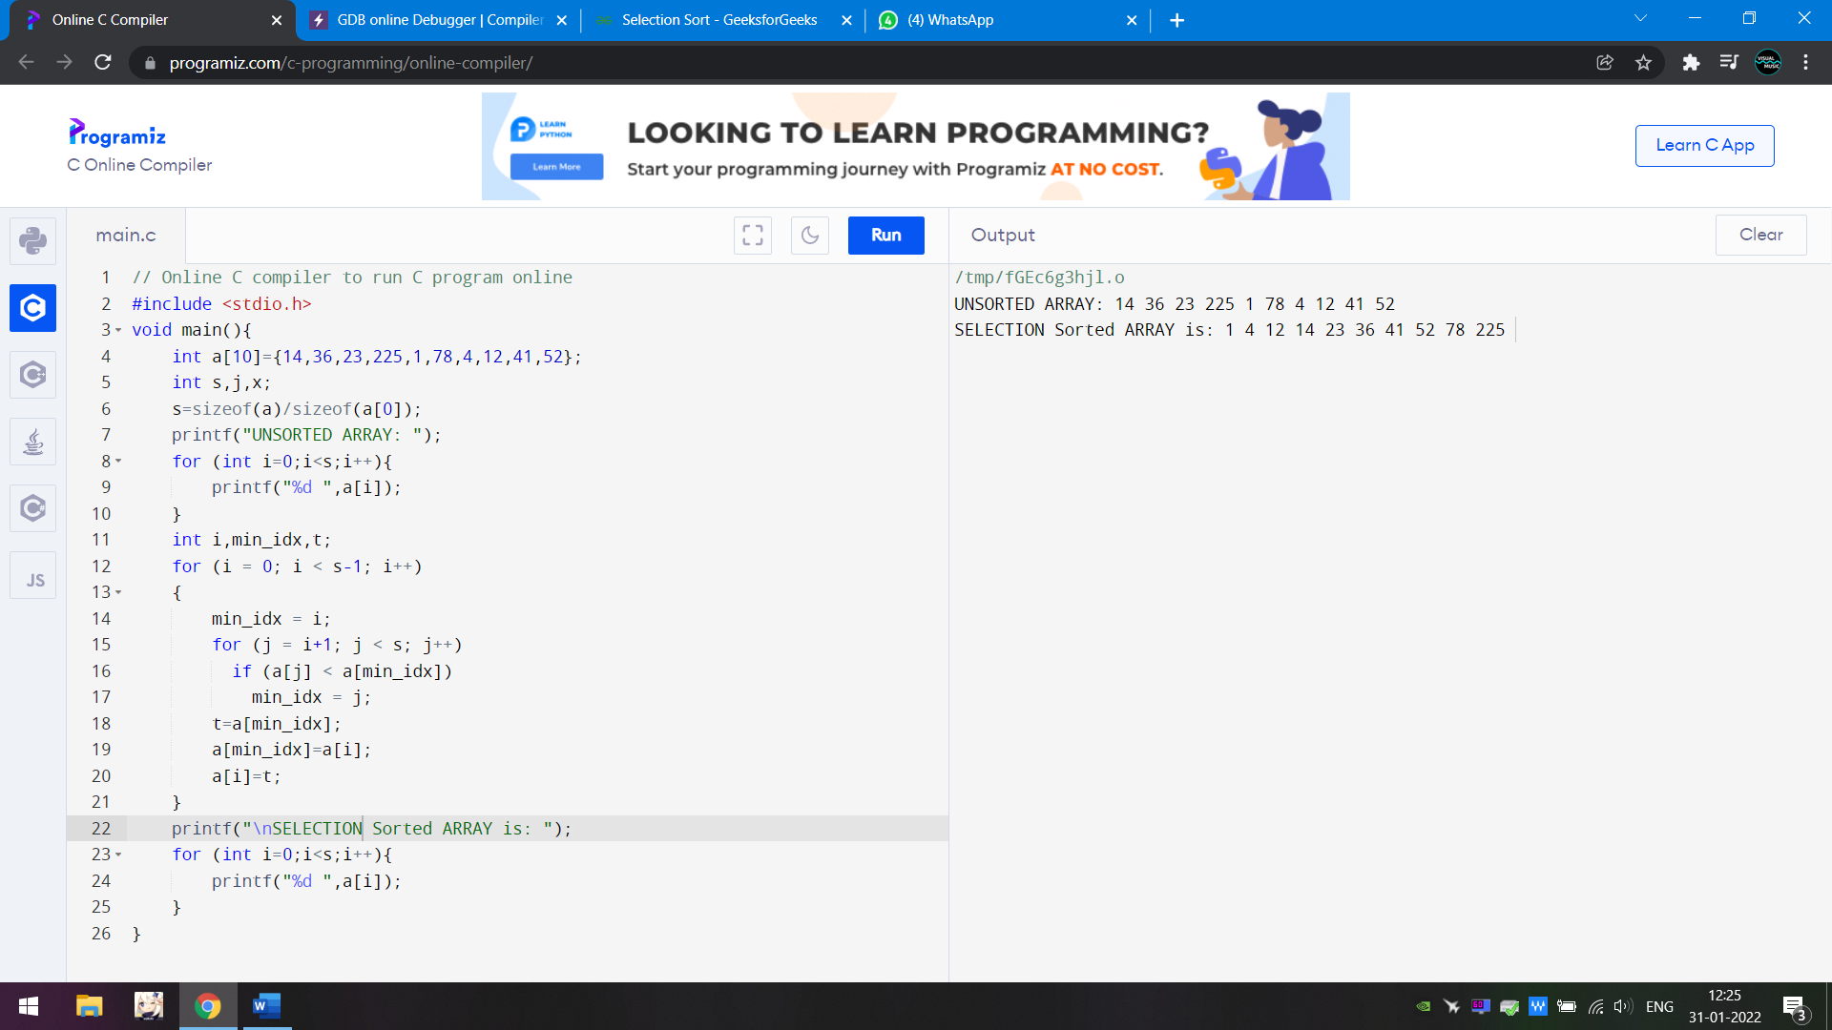 

36) WAP to read the information of a student from the keyboard and print the same on the screen using structure.

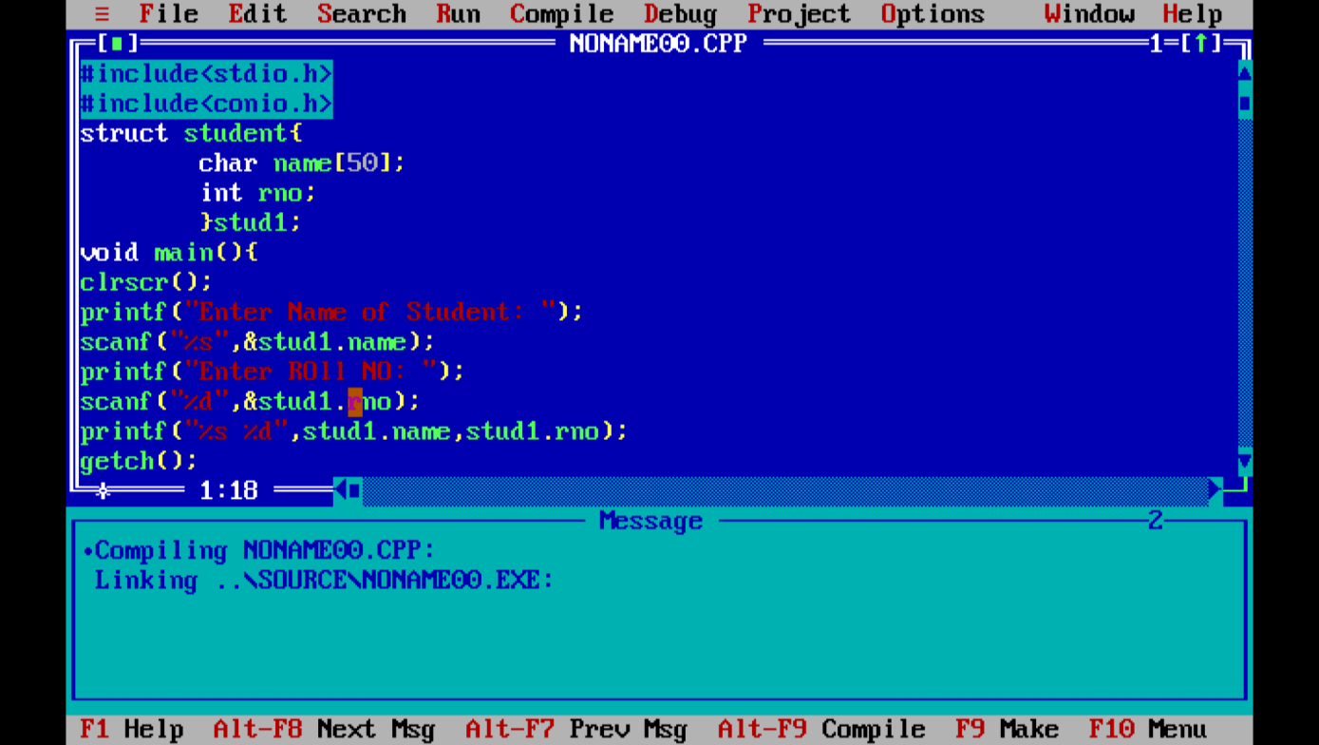 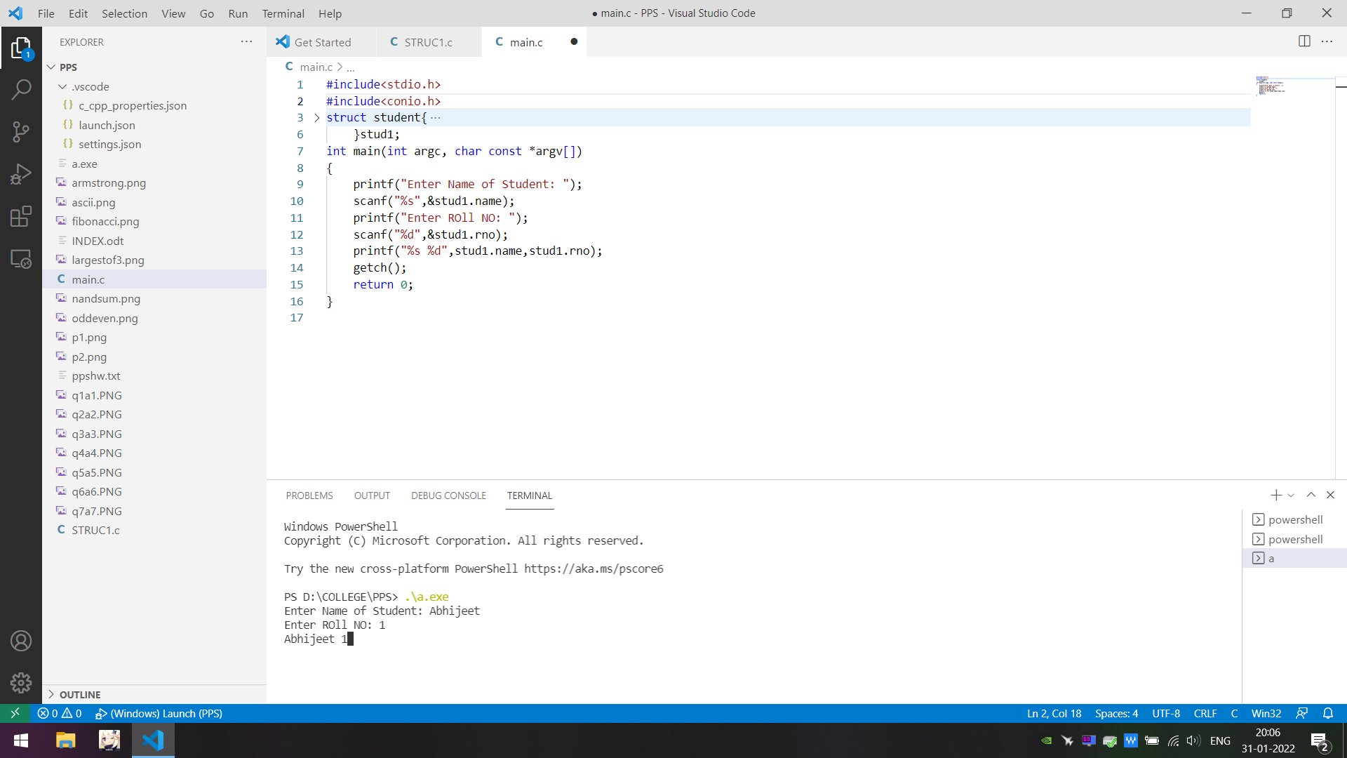

37) WAP to read information of n number of students from keyboard and and print the same by using structure.

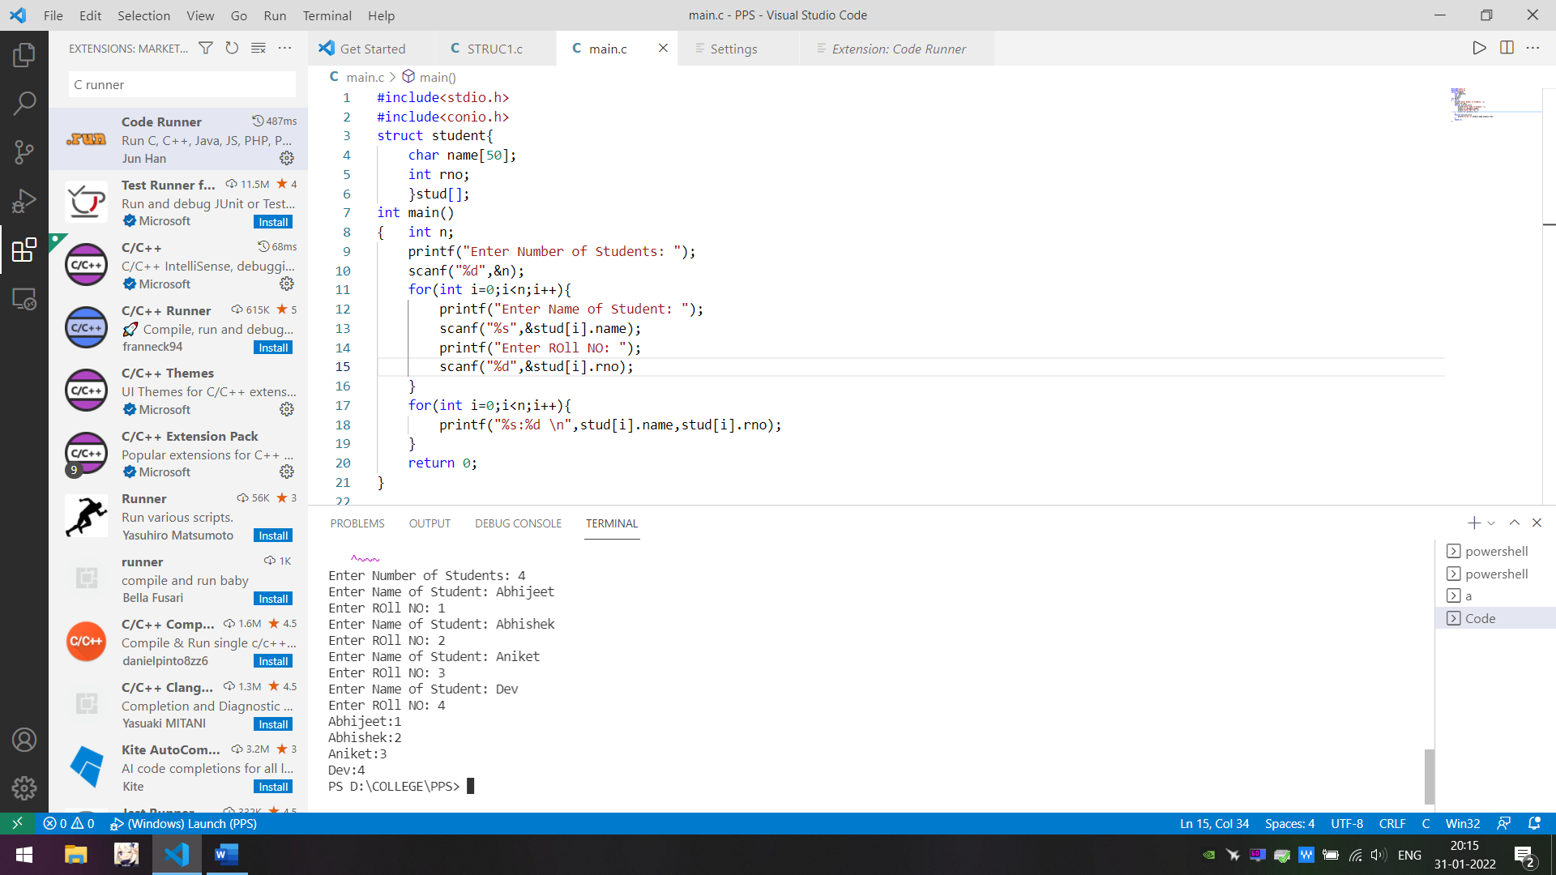

38) WAP to print a file on screen.

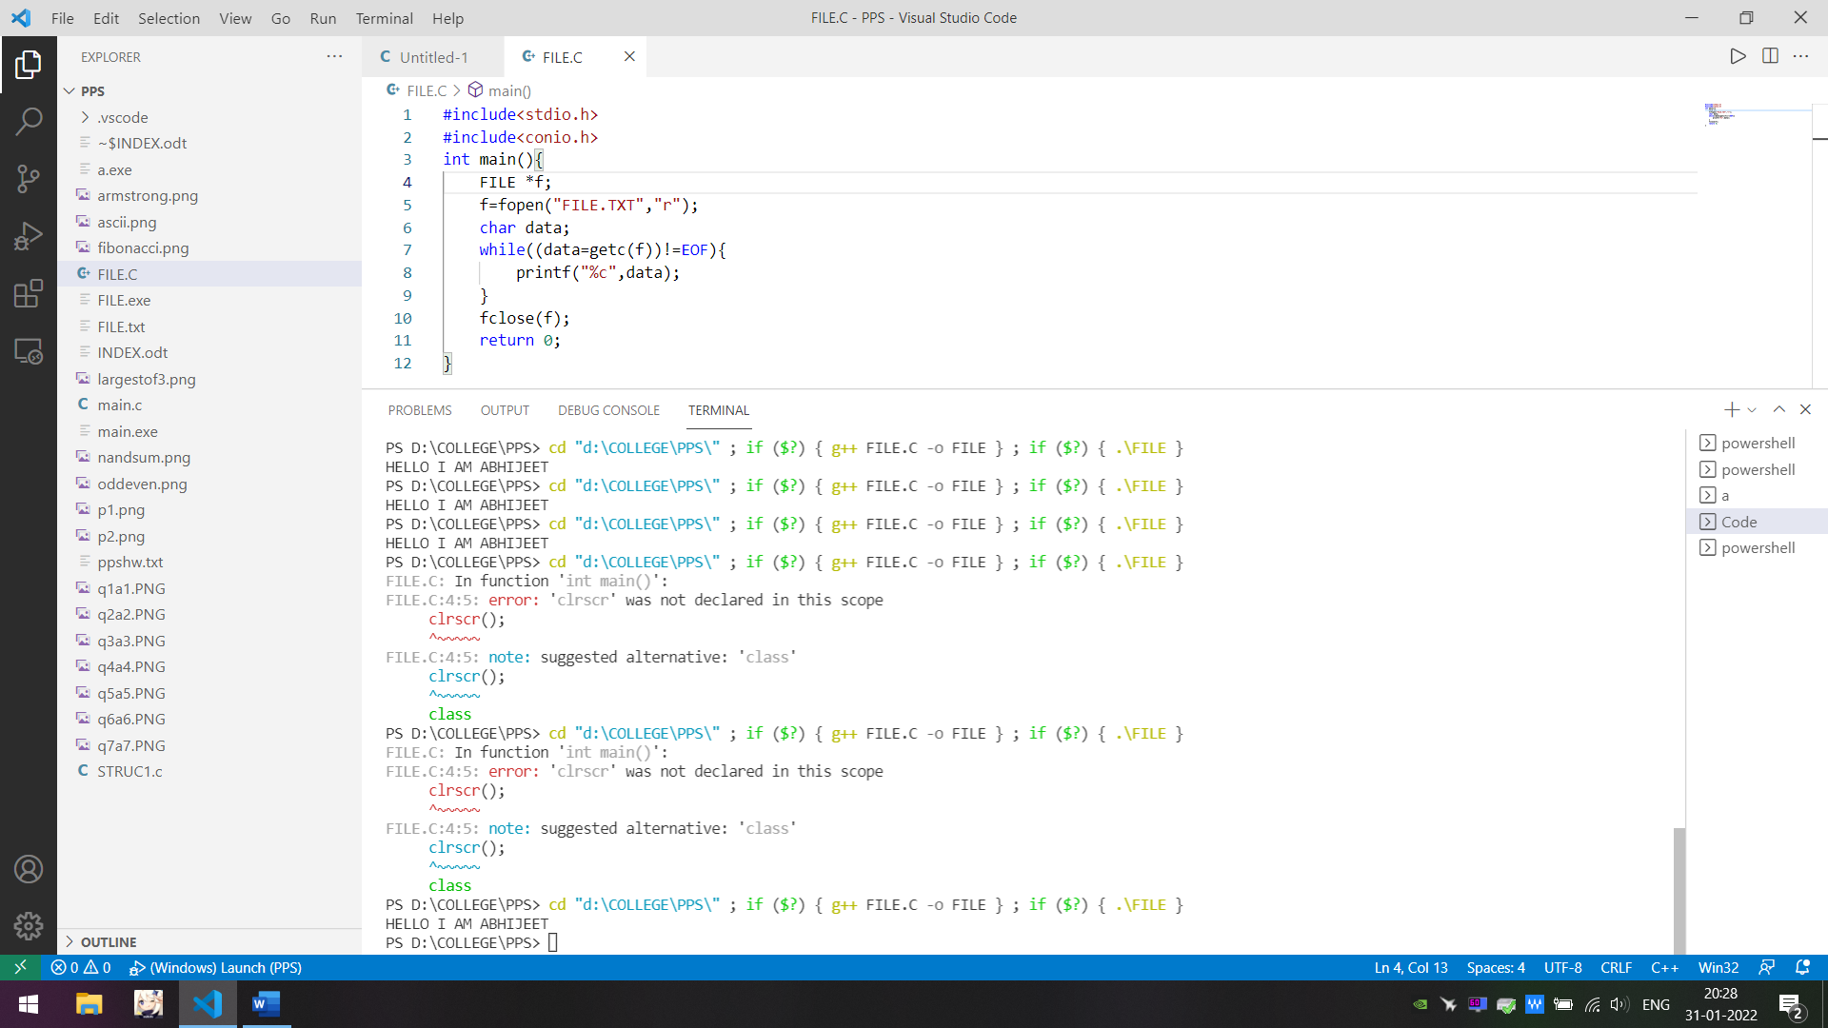 

39) WAP to copy the contents of one file to another file.

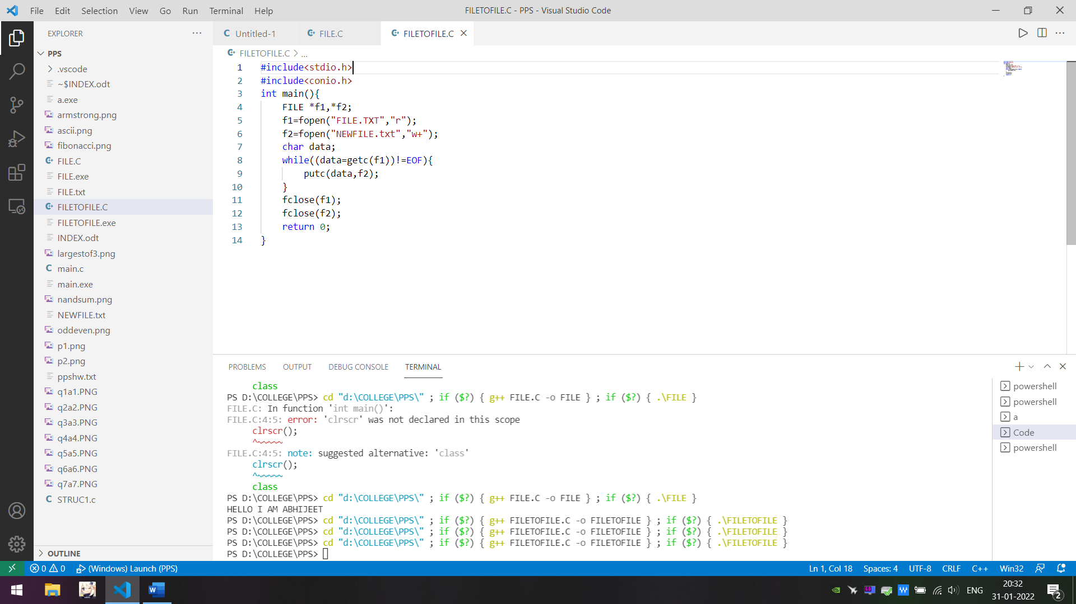

40) WAP to create a file named INPUT which contain a series of integers. Now read these integers from INPUT file and write all even numbers into a file to be called EVEN and all odd numbers into a file to be called ODD.

